9th

Annual

Where:
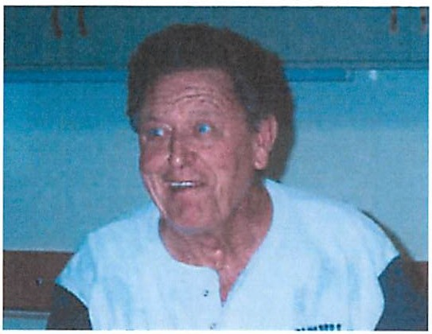
Bradshaw Ranch Golf Course
7350 Bradshaw Road

Aldino Golf Outing
Sign up as a group or individually

Players -

1.

2.

3.

4.

Please contact the hall with any questions - 916/457-6595
Sacramento, CA 95829

When:
July 16, 2022

Tee Time:
5:00 p.m. - Shotgun Start
- show up time 4:30 p.m.
- 2 Clubs (plus putter)
- 4 Man Best Ball
- Power Carts are extra - Pay at the course - Make your own cart reservations.
- Dinner will be served at the course after the first nine.
Cost:
$40.00 per member
$50.00 per non-mbr. (space permitting) (due no later than July 1st). Please bring/mail completed form and payment to the hall. Checks to be made out to "Local 447 Social Fund" or you can call in with credit/debit card. There is a $1.50 fee for a transaction up to $60.00. After that, there is a 2.5 % fee for the amount processed.

